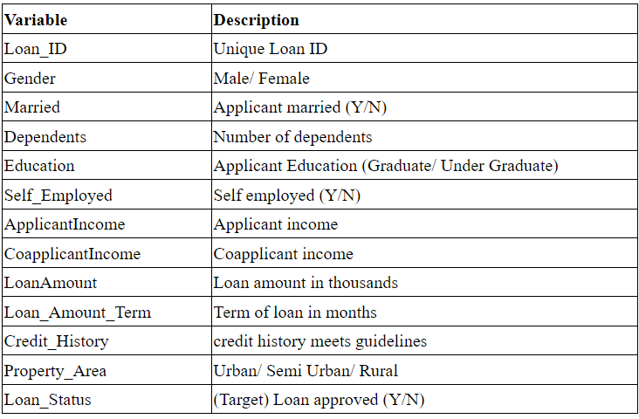

**Understanding the Problem Statement**

Dream Housing Finance company deals in all kinds of home loans. They have a presence across all urban, semi-urban and rural areas. The customer first applies for a home loan and after that, the company validates the customer eligibility for the loan.

The company wants to automate the loan eligibility process (real-time) based on customer detail provided while filling out online application forms. These details are Gender, Marital Status, Education, number of Dependents, Income, Loan Amount, Credit History, and others.

To automate this process, they have provided a dataset to identify the customer segments that are eligible for loan amounts so that they can specifically target these customers.

You can find the complete details about the problem statement [here](https://datahack.analyticsvidhya.com/contest/practice-problem-loan-prediction-iii/#ProblemStatement) and also download the training and test data.

As mentioned above this is a Binary Classification problem in which we need to predict our Target label which is “Loan Status”.

Loan status can have two values: Yes or NO.

Yes: if the loan is approved

NO: if the loan is not approved

So using the training dataset we will train our model and try to predict our target column that is “Loan Status” on the test dataset.

[**https://www.analyticsvidhya.com/blog/2021/10/loan-status-prediction-using-support-vector-machine-algorithm/**](https://www.analyticsvidhya.com/blog/2021/10/loan-status-prediction-using-support-vector-machine-algorithm/)

[**https://medium.com/@pinnzonandres/loan-prediction-with-python-d32cf65b5443**](https://medium.com/@pinnzonandres/loan-prediction-with-python-d32cf65b5443)

[**https://www.projectpro.io/article/loan-prediction-using-machine-learning-project-source-code/632**](https://www.projectpro.io/article/loan-prediction-using-machine-learning-project-source-code/632)

[**https://www.youtube.com/watch?v=XckM1pFgZmg&feature=youtu.be**](https://www.youtube.com/watch?v=XckM1pFgZmg&feature=youtu.be)